|  |
| --- |
| FR2052a Liquidity Profile Reporting, Bank of China, USA |
| Data Control and Validation Document |

|  |  |
| --- | --- |
| Current version: | 1.1 |
| Production unit： | FMD |
| Author： | TBD |
| Signer： | TBD |
| Signature Date | July 12, 2017 |

|  |  |  |  |  |
| --- | --- | --- | --- | --- |
| Version Control Table | | | | |
| Version # | Date | # of Pages | Status | Changes and remarks |
| 1.0.0 | 7/12/2017 | 13 |  | Version for BOC US review |
| 1.1 | 7/25/2017 | 12 |  | Updated section 5.8 - Report / Aggregate values less than zero  Included section 5.9 - Report / Aggregate values less than $5000 |
|  |  |  |  |  |

Contents

2 Purpose 2

3 Data flow diagram 2

4 FR2052a Validation (sp_FR_Validation) 2

5 Application data validation / control 3

5.1 Extract, Transform and Load (ETL) Control 3

5.2 Data Mapping 4

5.3 Foreign Exchange (fn_CurrencyExchange) 4

5.3.1 Reporting date doesn’t exist in the foreign exchange table 4

5.3.2 Currency to be converted doesn’t exist in the foreign exchange table 5

5.3.3 Currency to be converted is NULL or blank 5

5.4 Maturity Bucket 6

5.4.1 Maturity date is earlier than the reporting date 6

5.5 Required tables and mandatory fields 7

5.5.1 Required tables don’t exist in the SQL Server (sp_RequiredTableCheck) 7

5.5.2 Required tables exist but have zero records (sp_RequiredTableCheck) 7

5.5.3 Mandatory fields are blank or NULL (sp_RequiredFieldsCheck) 8

5.6 Signs of monetary value 8

5.6.1 Monetary values of a PID are of mixed signs (sp_MonetaryValueCheck ) 8

5.7 Calculation logic 9

5.7.1 Divide by zero errors 9

5.8 Report / Aggregate values less than zero (sp_RPT_FR2052a) 9

5.9 Report / Aggregate values less than $5000 (sp_RPT_FR2052a) 10

5.10 Current reference data 10

5.11 System errors 10

APPENDIX A: Sample Data 11

APPENDIX B: FR2052a Validation 11

# Purpose

This document describes validation outlined by FRB and implemented in FR 2052a application to check data prior to FRB submission. In addition, this document describes data control procedures implemented to check if key data values meet requirement.

# Data flow diagram

Data flow diagram below illustrates data objects (tables and stored procedures) used as BOC source data transfers through ETL (extract, transform and load) process to target tables, through aggregation table to XML report. The diagram illustrates data objects referenced throughout this document.

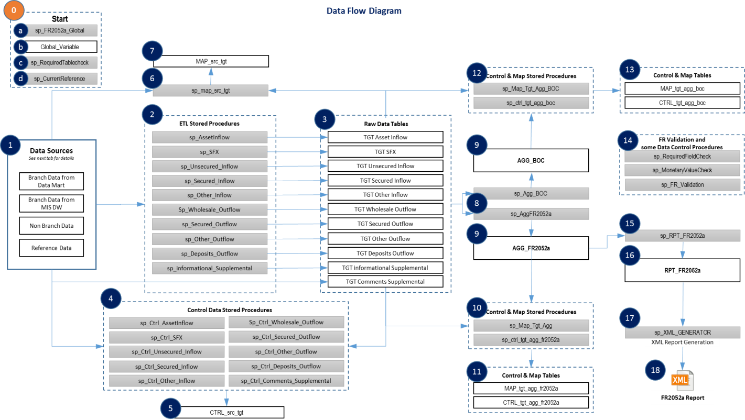

# FR2052a Validation (sp_FR_Validation)

This section discusses the implementation of FR 2052a validation checks outlined in *B. FR 2052a Validation Checks.pd*f document (See appendix B FRB Validation Document). The validation checks are implemented in *dbo.sp_FR_Validation* stored procedure and results (fails and warnings) logged in *app.FRValidationTracer* table. Table below show list of validations implemented and comments

| **#** | **FR2052a Validations** | **Comment** |
| --- | --- | --- |
| 1 | Weekend Maturities | Implemented |
| 2 | Internal Transactions Reported on Consolidated Reporting Entity | Not applicable as BOC is not a Consolidated Reporting Entity |
| 3 | Internal Transactions Reported Without Internal Counterparty | Implemented |
| 4 | Lendable Value in Excess of Market Value | Implemented |
| 5 | 3rd-Party Reporting Entity Exposures versus Consolidated | Not applicable as BOC is not a Consolidated Reporting Entity |
| 6 | Symmetry of Intercompany Transactions | Implemented. Compare total maturity value of Inflows to Outflow internal records. Comparison performed by Report Scope, Internal Counterparty, Currency and Internal. |
| 7 | Large Haircuts on Secured Transactions | Implemented |
| 8 | Mismatched Currency Reporting | Not applicable as monetary values are reported in USD |
| 9 | Missing Required Products by Entity Type | Implemented |
| 10 | Improper Intra-entity Consolidation | Implemented |
| 11 | Duplicate Records | Implemented |
| 12 | Invalid or Missing Counterparty Field | Implemented |
| 13 | Missing or Not Applicable [Collateral Class] Field | Implemented |
| 14 | Large Other Product or Counterparty Balance | Implemented |

# Application data validation / control

This section describes procedures implemented in FR2052a application to check if values of key fields or values used in calculations meet requirement and to manage potential errors. The procedures perform checks, store results of checks and manage associated errors.

## Extract, Transform and Load (ETL) Control

The application includes a process to compare and reconcile data extracted from BOC source tables to target tables in the application (source-to-target). The application also includes procedures to compare and reconcile data from target tables to aggregate tables (target-to-aggregate) by product. The comparison is performed by control stored procedures and results stored in control tables. The control tables contain product summary information about data transferred from one location to another and used for data reconciliation including portfolio, counterparty, source table, count of records, sum of monetary value and result of comparison (Pass or Fail).

All products are expected to pass ETL control process except for I.A1 (Unencumbered Assets) and I.O.8 (Principal Payments Receivable on Unencumbered Investment Securities). Due to complex nature of calculations and aggregation performed, I.A.1 and I.O.8 comparison during target-to-aggregation process does not reconcile using current comparison process. BOC should perform independent comparisons for I.A.1 and I.O.8 products as part of BOC reconciliation process.

The application inserts a “warning” message in the Issue Trace table if a source-to-target or target-to-aggregate comparison fails. Example of a source-to-target message is “Validation Check Fail in Ctrl_Src_Tgt”.

ETL control stored procedures include:

| # | Process | Stored Procedure Name | Table |
| --- | --- | --- | --- |
| 1 | Source-to-target | sp_Ctrl_deposits_outflow | CTRL_src_tgt |
| 2 | sp_Ctrl_ForeignExchange |
| 3 | sp_Ctrl_Informational_Supplemental |
| 4 | sp_Ctrl_Other_Inflow |
| 5 | sp_Ctrl_Other_outflow |
| 6 | sp_Ctrl_Secured_Inflow |
| 7 | sp_Ctrl_Secured_Outflow |
| 8 | sp_Ctrl_Unsecured_Inflow |
| 9 | sp_Ctrl_wholesale_outflow |
| 10 | Target-to-aggregate | sp_Ctrl_Tgt_Agg_BOC | CTRL_tgt_agg_boc |
| 11 | sp_Ctrl_Tgt_Agg_FR2052a | CTRL_tgt_agg_FR2052a |

## Data Mapping

The application includes a process to map the column values between tables during ETL source-to-target and target-to-aggregation processes. The mapping tables contain unique identifying column(s) in one table mapped to next table in the application. The mapping is performed by map stored procedures and results stored in map tables shown below. The mapping process is created for informational purposes and does not create or insert messages in ISsueTracer table.

| # | Process | Stored Procedure Name | Table |
| --- | --- | --- | --- |
| 1 | Source-to-target | sp_Map_Src_Tgt | Map_Src_Tgt |
| 2 | Target-to-aggregate | sp_Map_Tgt_Agg | Map_Tgt_Agg |
| 3 | sp_Map_Tgt_Agg_BOC | Map_Tgt_Agg_BOC |

## Foreign Exchange (fn_CurrencyExchange)

The Foreign exchange (FX) function dbo.fn_CurrencyExchange accepts parameters (Currency, Amount and Report Date), performs conversion of provided amount to USD based on exchange rate as of Report Date, and returns the converted value.

### Reporting date doesn’t exist in the foreign exchange table

This test is implemented at the first step of the function, to check if report date exists in Foreign Exchange table Src.FBNK_Currency. If Report Date is not found in the Foreign Exchange table Src.FBNK_Currency, a record is inserted into APP.IssueTracer with issue description “Asofdate does not exist in the Foreign Exchange Table” and the application stops executing. The status of the issue is “Fail”.

The image below shows the results when the application is executed using reporting date = 3/30/2017 and underlying data including FX is as of 4/28/2017.

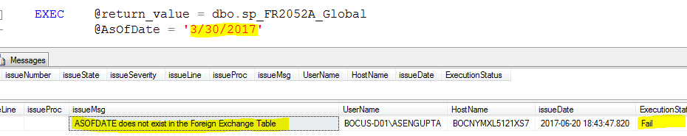

### Currency to be converted doesn’t exist in the foreign exchange table

This test is implemented in the FX function, to check if exchange rate record for the currency parameter exists in the Foreign Exchange table Src.FBNK_Currency. If exchange rate record for the currency parameter is not found in the Foreign Exchange table Src.FBNK_Currency, the monetary value is reported as it is sourced. A comment is inserted in EVENT column of the target table with issue description ‘Currency code unavailable in ref tables identified’. The description is also inserted as a record into the APP.IssueTracer table along with details of PID exhibiting this issue. The status of the issue is “Warning”

**Tab *Test FX***contains raw data that have dummy Currencies such as ‘abc’, ‘def’ and ‘123’ . (See Cells T6, T14, T17, T21, T25, T26, T28, T34, T39)

**Tab Test FX Results 1** contains the results of the target table.

**Tab Test FX Results 2** contains the results of the issuetracer table.

The image below shows the EVENT column from the target table if this test fails.

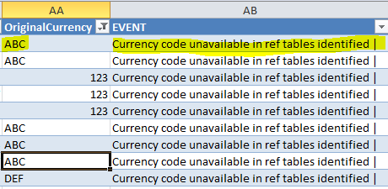

The image below shows the app.IssueTracer, if this test fails.



### Currency to be converted is NULL or blank

This test is implemented in the function dbo.fn_CurrencyExchange, to check if the currency to be converted is NULL or blank. If currency is NULL or blank, the monetary value is reported as it is sourced. A record is inserted in EVENT column of the target table with the text ‘Null or blank currency code identified’. This text is also inserted as a record into the APP.IssueTracer table so that the PID exhibiting this can be traced. The status of the issue is “Warning”.

**Tab Test FX**contains raw data that have NULL or blank currency values. (See Cells T11, T19, T30)

**Tab Test FX Results 1** contains the results of the target table.

**Tab Test FX Results 2** contains the results of the issuetracer table.

The image below shows the EVENT column from the target table if this test fails.

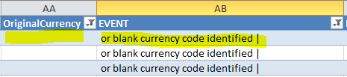

The image below shows the app.IssueTracer, if this test fails.



## Maturity Bucket

### Maturity date is earlier than the reporting date

This test is implemented in the source to target stored procedures, to check if the maturity date is earlier than the reporting date. If the maturity date is earlier than the reporting date, maturity bucket is reported as blank. A record is inserted into the EVENT column of the target table with the text ‘Maturity Date earlier that reporting date identified’. This text is also inserted as a record into the APP.IssueTracer table so that the PID exhibiting this can be traced. The status of the issue is “Warning”.

**Tab Test maturity**contains raw data that have NULL or blank currency values. (See Cells E5, E14, E23, E27, E39)

**Tab Test maturity Results 1** contains the results of the target table.

**Tab Test maturity Results 2** contains the results of the issuetracer table.

The image below shows the EVENT column from the target table if this test fails.

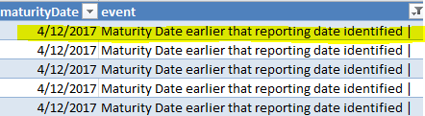

The image below shows the app.IssueTracer, if this test fails.



## Required tables and mandatory fields

### Required tables don’t exist in the SQL Server (sp_RequiredTableCheck)

This test is implemented in the sp_RequiredTableCheck stored procedure, to check if the tables to be sourced, exists in the system. If certain tables are not available in the system, a record is inserted into the APP.IssueTracer table with the text ‘[Table name] doesn’t exist in the system'. If certain tables are not available in the system, the PIDs requiring these tables will not be executed, so that the application is not affected by the unavailable tables. The status of the issue is “Fail”.

In case of a scenario where the following tables don’t exist in the system, for I.S.7, this test will fail.

* src.fbnk_currency
* src.multi_ld_schedule_define_detail
* src.multi_ld
* src.fbnk_limit
* src.fbnk_collateral_right
* src.fbnk_collateral

The image below shows the app.IssueTracer, if this test fails.

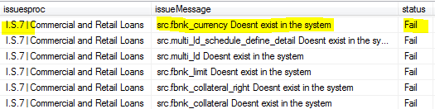

### Required tables exist but have zero records (sp_RequiredTableCheck)

This test is implemented in the sp_RequiredTableCheck stored procedure, to check if the tables to be sourced have records. If required tables don’t have records, a record is inserted into the APP.IssueTracer table with the text ‘[Table name] has 0 records'. The status of the issue is “Fail”. If required tables don’t have records, the PIDs requiring these tables will not be executed, so that the application is not affected by the unavailable tables.

In case of a scenario where the following tables have zero records in the system, for I.S.7, this test will fail.

* src.fbnk_currency
* src.multi_ld_schedule_define_detail
* src.multi_ld
* src.fbnk_limit
* src.fbnk_collateral_right
* src.fbnk_collateral

The image below shows the app.IssueTracer, if this test fails.

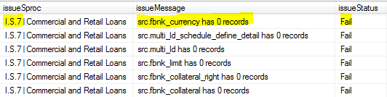

### Mandatory fields are blank or NULL (sp_RequiredFieldsCheck)

This test is implemented in the sp_RequiredFieldsCheck stored procedure, to check if the mandatory fields (as per FR2052a instructions) in the target tables are blank or NULL. If a mandatory field is not populated, a record is inserted into the APP.IssueTracer table with the text ‘[Field Name] not populated'. The PID is also recorded so that it can be traced back in the application. The status of the issue is “Warning”.

**Tab Test Mandatory Fields**contains raw data that have NULL or blank Collateral Types. (See Cells CJ4,5,6,7, etc.)

**Tab Test Mandatory Fields Results**contains the results of the issuetracer table.

The image below shows the app.IssueTracer, if this test fails.



## Signs of monetary value

### Monetary values of a PID are of mixed signs (sp_MonetaryValueCheck )

This test is implemented in the sp_MonetaryValueCheck stored procedure, to check if a PID contains monetary values of mixed signs (positive and negative). If a PID contains monetary values of mixed signs, a record is inserted into the APP.IssueTracer table with the text ‘[Field Name] has opposite signs’. The PID is also recorded so that it can be traced back in the application. The status of the issue is “Warning”.

**Tab Test Mixed Signs**contains raw data that have monetary values of mixed signs. (See Cells H14, H22, H32, H46)

**Tab Test Mixed Signs Results**contains the results of the issuetracer table.

The image below shows the app.IssueTracer, if this test fails.

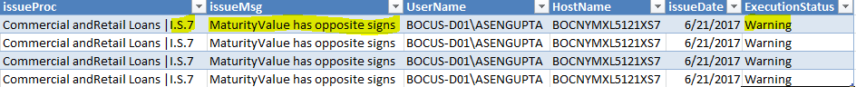

## Calculation logic

### Divide by zero errors

This test is implemented in the source to target stored procedures, if there is a division involved in the calculation. If divide by zero is encountered, the monetary value is reported as zero and a record is inserted into the EVENT column of the target table with the text ‘0 denominator identified’. A record is inserted into the APP.IssueTracer table as well. The PID is also recorded so that it can be traced back in the application. The status of the issue is “Warning”.

**Tab Test Divide by 0** contains raw data that have maximum_Total values as zero , which is the denominator in the collateral value calculation. (See Cells IC7, IC10, IC15, IC20, IC25, IC29, IC43,IC49)

**Tab Test Divide by 0 Results 1**contains the results of the EVENT Column in the target Table

**Tab Test Divide by 0 Results 2**  contains the results of the issuetracer table.

The image below shows the EVENT column from the target table if this test fails.

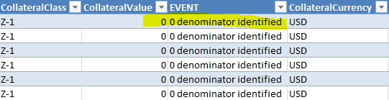

The image below shows the app.IssueTracer, if this test fails.

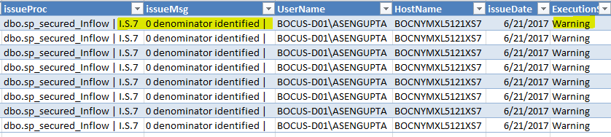

## Report / Aggregate values less than zero (sp_RPT_FR2052a)

The FR 2052a report should not include any negative values. Values reported in maturity amount, market value, lendable value, collateral value and forward start value fields should all be positive numbers.

The application checks for negative monetary values when creating the report table (RPT_FR2052a) from aggregate table. Identified negative values are recorded in Issue Tracer table and removed from Report Table. This check is performed in sp_RPT_FR2052a stored procedure and “*Removed PID containing negative Monetary values*” recorded in app.IssueTracer table if test fails.

## Report / Aggregate values less than $5000 (sp_RPT_FR2052a)

The FR 2052a report requires monetary values to be reported in millions (M). In addition, report values are required to be greater than zero (non-zero) and reported up to two decimal places. To meet reporting in millions, non-zero and two decimal places requirements, original aggregated values less than 5000 are removed from Report Table since they are insignificant when reported in millions to decimal places.

The application checks for monetary values less than $5000 when creating the report table (RPT_FR2052a) from aggregate table. Identified values are recorded in Issue Tracer table and removed from Report Table. This check is performed in sp_RPT_FR2052a stored procedure and “*Removed Monetary values less than 5000*” message is recorded in app.IssueTracer table if test fails.

## Current reference data

It is understood from BOC that data in some reference tables are expected to remain fairly constant with minor updates required occasionally. When updates are required to such tables, incremental not complete change records will be inserted in the table.

The application checks the tables in SRC schema and creates current versions of the tables in APP schema that contain the latest records. This check is performed in sp_CurrentReference stored procedure. The check does not record a status in Issue Tracer table as it does not result in a pass or fail.

|  |  |  |
| --- | --- | --- |
| **#** | **Source (SRC) Schema Table** | **Application (APP) Schema Table** |
| 1 | src.US_FR2052A_REF_CDARS | app.US_FR2052A_REF_CDARS |
| 2 | src.US_FR2052A_REF_CID_Exception | app.US_FR2052A_REF_CID_Exception |
| 3 | src.US_FR2052A_REF_COLLATERAL | app.US_FR2052A_REF_COLLATERAL |
| 4 | src.US_FR2052A_REF_Collateral_MISDW | app.US_FR2052A_REF_Collateral_MISDW |
| 5 | src.US_FR2052A_REF_CounterParty | app.US_FR2052A_REF_CounterParty |
| 6 | src.US_FR2052A_REF_CounterPartySTB | app.US_FR2052A_REF_CounterPartySTB |
| 7 | src.US_FR2052A_REF_DepositScope | app.US_FR2052A_REF_DepositScope |
| 8 | src.US_FR2052A_REF_Entity | app.US_FR2052A_REF_Entity |
| 9 | src.US_FR2052A_REF_EntitySTB | app.US_FR2052A_REF_EntitySTB |
| 10 | src.US_FR2052A_REF_InternalCounterParty | app.US_FR2052A_REF_InternalCounterParty |
| 11 | src.US_FR2052A_REF_InternalCounterPartySTB | app.US_FR2052A_REF_InternalCounterPartySTB |
| 12 | src.US_FR2052A_REF_OperationalDepositTag | app.US_FR2052A_REF_OperationalDepositTag |
| 13 | src.US_FR2052A_REF_ReportType | app.US_FR2052A_REF_ReportType |

## System errors

The application has a try-catch code in place for all stored procedures. In case of a system error, the issueTracer table will be populated with a record that will allow the user to trace it back to the stored procedure and line number. The issue tracer will contain a message explaining the system error and provide additional details. The application will stop executing the moment it encounters a system error.

# APPENDIX A: Sample Data

The following was tested for the above scenarios:

**Portfolio:** Commercial and Retail Loans

**PID:**  I.S.7

**Module:** Mortgage Principal

The attached spreadsheet contains source data (Tab *Source Data*) on which the tests are performed and the results are explained above. Tab *Raw data* shows the results of the product, if it passes all the test cases.



# APPENDIX B: FR2052a Validation

